How To: Create a Note
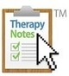
Jakki
TherapyNotes provides a variety of robust note templates to help you complete clinically-rich documentation quickly and easily. Each of our templates are specially designed for the unique needs of behavioral health professionals and combine dropdown menus, checkboxes, and text fields to balance speed and ease-of-use with person-centered documentation. An emphasis on organization and readability make our note templates ideal for audits.
Because TherapyNotes is built on a streamlined workflow, a corresponding appointment must be scheduled on the calendar in order to create most note types.

Creating Notes

Create a note from your To-Do list
Click To-Do
Whenever a scheduled appointment occurs, TherapyNotes automatically creates an item on the To-Do list to complete the note for that session.
Click on the link in the To-Do list item to create the corresponding note.

Create a note from the calendar
Click Scheduling > Click the appointment > Notes tab
Clicking on a completed appointment brings up a dialog with additional details regarding the appointment as well as related notes and billing items. The Notes tab of this dialog has links to complete notes that may be related to the session, including the appropriate session note, Process Note and Missed Appointment Note.
Click on the link for whichever note type you wish to create.

Create a note without an appointment
Click Patients > Patient Name > Documents tab
Not all documentation in TherapyNotes is associated with an appointment. To view all of the note templates that you have access to in TherapyNotes, click the Create Note button. A list of available note templates will appear.
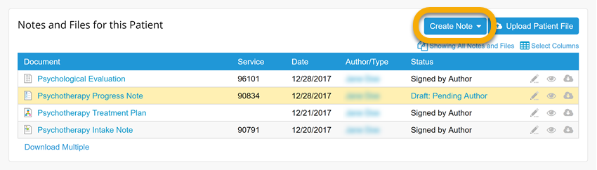
Different note types will be available in this dropdown depending on your role and clinician type (Psychotherapy or Medication Management). Note: Only Clinical Administrators, Clinicians, and Interns assigned to the client plus Supervisors for the assigned clinicians have access to create and view clinical notes. Non-clinical notes may be created by any user.
Below is a list of note templates available in TherapyNotes.
Psychotherapy Clinical Notes (Type of Clinician: Psychotherapy)
- Treatment Plan
- Termination Note
- Intake Note
- Progress Note
- Process Note
- Psychological Evaluation
- Consultation Note
Psychiatry Clinical Notes (Type of Clinician: Medication Management)
- Treatment Plan
- Termination Note
- Intake Note
- Progress Note
- Psychotherapy Process Note
- Consultation Note
Non-Clinical Notes (Accessible to Schedulers, Billers, and Clinicians)
- Contact Note
- Missed Appointment Note
- Miscellaneous Note

Note Tools
Each note template in TherapyNotes features various tools to further optimize note writing.

Quick History Review
The History button is available in most fields of almost every note template. Click the button to view the content that was entered in the same field in previous notes for that client, allowing you to ensure continuity between notes or refer to what was discussed in previous sessions. Click the Use button to pull previous content into the current note.
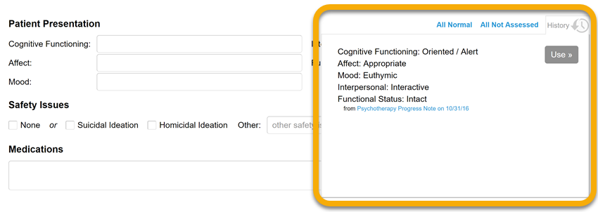

Searchable DSM-5 Diagnoses
Search for the diagnosis code or description in either of the Diagnosis fields, and TherapyNotes will find potential matches, helping you record diagnoses in a flash.

Autofill
Some note fields offer options to autofill the field with common responses. For these fields, simply click on the field, select a response, and the response will be automatically populated in the field. On some note templates, related fields may be autofilled simultaneously using the All Normal or All Not Assessed links in the upper right of the section.
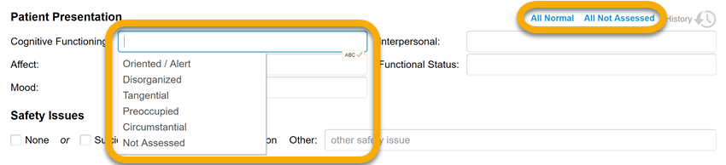

Spellcheck
All note templates include a built-in spellchecker supported by a customizable dictionary of commonly used mental health terms. Click in a field and click the ABC icon that appears in the bottom right corner of the field to run spellcheck on that field. Or, click the ABC button on the bottom of the note to run spellcheck on the entire note.
